Thalassemia Care Hub


Project Developed By
Usaid Ahmad 4475-FBAS/BSCS4/F21
Muhmmad Sarfraz Nawaz 4482-FBAS/BSCS4/F21
Supervisor
Dr. Qamar Abbas
Department of Computer Science
Faculty of Computing and Information Technology
International Islamic University, Islamabad
(2026)


"In the Name of Allah, the Most Beneficent, the Most Merciful"

FINAL APPROVAL
Date: ______________
We have certified that we have read the Project Report entitled Institute connect, having submitted by Usaid Ahmad (4475-FBAS/BSCS4/F21) and Muhmmad Sarfraz Nawaz (4482-FBAS/BSCS4/F21). We believe that the project is sufficiently good to recommend its acceptance by the International Islamic University, Islamabad on Bachelor’s Degree in Computer Science.
COMMITTEE
External Examiner:  Mr. Jahanzaib Ali Khan  Lecturer  Department of Computer Science  International Islamic University, Islamabad |  |  | _________________

Internal Examiner:  Dr. Muhammad Adeel  Assistant Professor  Department of Computer Science  International Islamic University, Islamabad |  |  | _________________
Supervisor: |  |  | _________________
Dr. Qamar Abbas
Department of Computer Science
International Islamic University, Islamabad

A dissertation submitted to
Department of Computer Science,
International Islamic University, Islamabad
As partial fulfillment of the requirements
For award of the degree of
Bachelors in Computer Science.

DEDICATION
We assign this meager attempt to our dear parents and decent teachers to their infinite support, lovingness, trust and stimulation, and to our supervisor Dr. Qamar Abbas, who has been a great source of encouragement and motivation, to whom we gave our entire trust since the onset of our project.
Usaid Ahmad
4475-FBAS/BSCS4/F21
Muhmmad Sarfraz Nawaz
4482-FBAS/BSCS4/F21

DECLARATION
It is hereby stated that the issuance of this report is well developed due to our own contribution and education with the unconditional help of our project supervisor Dr. Qamar Abbas and under his genuine interest and encouragement. Nothing included in this report has been offered to support our application to any other degree in any other university or institute of learning. We also state that this project, the code and related documents and reports are placed as incomplete requirements of the degree of Bachelors of Science in Computer Science.
Usaid Ahmad
4475-FBAS/BSCS4/F21
Muhmmad Sarfraz Nawaz
4482-FBAS/BSCS4/F21

ACKNOWLWDGEMENT
The first and most important thing we would like to direct our thanks with Allah Almighty who blessed us with a will and a desire to do this project. He allowed us to capitalize on our abilities, investigation and efforts it took to construct this project. Our confident gratitude, once again, would certainly be to our supervisor Dr. Qamar Abbas who was outstanding in supervising the course of the project completion. It is true that due to his teachings we managed to carry out every job without hesitation. Finally, we would like to express our gratitude to all the other teachers and lab assistants who helped a lot.

PROJECT IN BRIEF

Project Title: | Thalassemia Care Hub
Version: | 1.0
Undertaken By: | Usaid Ahmad  Muhmmad Sarfraz Nawaz
Supervised By: | Dr. Qamar Abbas
Date Started: | February 2025
Date Completed: | July 2025
Tools, Technologies and Languages Used: | Visual Studio Code, local host Server, React, ASP.NET, Fast API, TypeScript, Python, C#, Azure or AWS for hosting, Dialog flow or Microsoft Bot Framework for chatbots
System Used: | Core-i5, RAM-16GB, Microsoft Windows 10/11

ABSTRACT
Thalassemia is a incurable genetic blood condition that poses the patients an enormous load as they have to undergo regular and constant blood transfusion in order to survive. In most modern healthcare settings, the management of this condition is still very manual and as such, involves use of paper documents or individual digital files that cause some dangerous delays in locating compatible donors and monitoring of medical history. Sometimes these inefficiencies lead to life threatening conditions where patients may run out of blood during crucial time deadlines.
The Thalassemia Care Hub is an all-encompassing, centralized digital hub that aims at eliminating these gaps by linking patients, donors, physicians, and administrators all through a single web platform. In addition to the standard blood inventory management, there is a social layer of the community where a patient and a medical professional can interact in a manner similar to contemporary social media. Registered users have the freedom to post, exchange experiences and interact and connect with other users through likes and comments which form the support system that tackles the emotional burden of the disease.
One of the main novelties of this platform is the application of a specialized AI Thalassemia Assistant. This model will be trained to be custom Designed which will need instant and trusted information about Thalassemia symptoms, management of the disease and general health related questions which can serve as a 24/7 support system to the patients. Also, the system has verified news portal to provide correct medical updates and institutional news to the community; this is controlled by administrators.
The system is implemented technically in terms of a strong multi-tier structure, which comprises of ASP.NET as a backend logic, React as the responsive user interface, and SQL Server as the data storage interface. By adding computerization to the donation lifecycle of smart donor matching and FIFO-based inventory control to computer-generated transfusion notification the Thalassemia Care Hub will help cut the procurement time, maintain the integrity of the data and improve the quality of life of Thalassemia majors with timely and community-driven intervention.

Table of Contents
- Introduction 1
  - Overview 2
  - Problem Statement 2
  - Objectives 3
  - Project Scope 3
  - Use Case Diagram 4
  - Use Case Descriptions (Brief) 5
  - Use Case Description (Detailed) 6
- System Analysis 8
  - Introduction to Analysis Models 9
  - System Sequence Diagrams (SSD) 9
  - Operation Contracts 12
  - Conceptual Model (Domain Model) 13
  - Activity Diagrams 14
  - Detailed Sequence Diagrams 15
- System Design 16
  - Design Philosophy 17
  - Database Design (Data Dictionary) 18
  - Class Diagram 21
  - AI Assistant Architecture 22
  - Component Diagram 22
  - Deployment Plan 23
- Implementation 24
  - Development Environment 25
  - Deployment Diagram 26
  - Database Implementation (SQL) 27
  - AI Model Logic & Algorithm 38

- System Testing 39
  - Testing Strategy 40
  - Test Cases 41
  - Summary 44
- Conclusion 45
  - Summary of the Project 46
  - Achievements 46
  - Limitations and Future Work 47
- User Manual 48
User Manual 49
A.1 For Visitors (Unregistered Guests) 49
A.2 For Registered Users (Patients/Doctors) 50
A.3 For Administrators 51
References 52

List of Figures

Figure No. | Correct Figure Title | Page No.
Figure 1.1 | Primary Actors (Use Case Diagram) | 4
Figure 2.1 | Asking the AI Assistant a Question (SSD) | 10
Figure 2.2 | User Posting to Community (SSD) | 11
Figure 2.3 | Conceptual Model (Domain Model) | 13
Figure 2.4 | Visitor to Registered User Workflow (Activity Diagram) | 14
Figure 3.1 | Class Diagram | 21
Figure 3.2 | Physical Separation of the System’s Parts (Component Diagram) | 22
Figure 4.1 | Deployment Diagram | 26
Figure 4.2 | AI Model Architecture | 38
Figure 5.1 | New User Sign-Up Screen | 41
Figure 5.2 | Post by User (Usaid Ahmad) | 42
Figure 5.3 | AI Model Interaction Screen | 43
Figure 7.1 | How to Create Post | 50
Figure 7.2 | News Posting Management | 51
Figure 7.3 | Users Management | 52

CHAPTER 01
INTRODUCTION

Introduction
The introduction chapter presents the background of Thalassemia Care Hub project. It creates a need to have a digital intervention in the lives of Thalassemia patients and why this system is not similar to the conventional blood bank management software. The chapter discusses the background of the project, the target problems that the project aims to address, the main objectives, and the scope of the work technically. Besides, it provides the functional requirements by introducing the Use Case modeling, a blueprint of the development of the whole system.

1.1 Overview
Thalassemia is a genetic blood disorder that is chronic and it does not allow the production of enough hemoglobin in the body which is the protein in the red blood cells that carries oxygen. In nations such as Pakistan where Thalassemia is being major, patients have a life long fight. This is not another battle, but social and informational. Patients usually have a challenging time finding trusted blood donors, verifiable medical information, and a community that can empathize with them on their hard situations.
Thalassemia Care Hub is a thalassemia education center web platform that will address these problems. It transcends the position of a mere database. Although it is a serious program that is used to manage blood inventory and donor matching, it is not neglected of the new socialized aspects. Patients, doctors, and donors can communicate on the platform in a social-media-like environment; they can update, like, and comment. Most importantly, it presents an AI Thalassemia Assistant, the chatbot that was specifically trained to support users with their symptom management and disease information. These features will be centralized as part of the project to establish a one-stop shop to Thalassemia community.

1.2 Problem Statement
At the moment, the needs management associated with Thalassemia is dispersed and ineffective. This has identified the major issues as:
- Inefficient Blood Procurement: Most blood centers use manual phone calls and unplanned posts on social media in order to locate blood, thus resulting in delays that may be life-threatening to a patient in need of a transfusion.
- Information Overload and Misinformation: Patients often search the internet for symptoms or diet advice and find conflicting or incorrect information.
- Social Isolation: There is no dedicated platform where Thalassemia patients can share their journeys or where doctors can provide public health advice in an interactive format.
- Lack of Real-time Coordination: There is no bridge between the news (health alerts, blood shortages) and the community who can actually respond to those needs.

1.3 Objectives
The objectives of this project can be specific to it:
- To build an AI-Powered Chatbot that serves as a 24/7 knowledge base for Thalassemia patients.
- To create a Community Feed that allows all users to post experiences, like, and comment, creating a social support structure.
- To implement a Verified News Portal where administrators can post critical updates accessible to all users.
- To provide an environment where visitors get knowledgeable about Thalassemia, and encourage them who participate in Thalassemia Care.

1.4 Project Scope
The project scope includes development of web-based portal that is secure. It includes:
- User Management: Registration and profiles for User, Visitor (Patients, Donors, Doctors) and Admins.
- Social Interaction: A front-end interface for making posts, commenting, and liking.
- News Management: A restricted module for admins to publish official news.
- AI Integration: A chat interface connected to a trained NLP model for Thalassemia queries.
- Note: This system does not include payment processing.

1.5 Use Case Diagram
The interactions between the main actors (Admin, Patient, Visitor, Doctor) and the system are depicted on the Use Case diagram presented below.

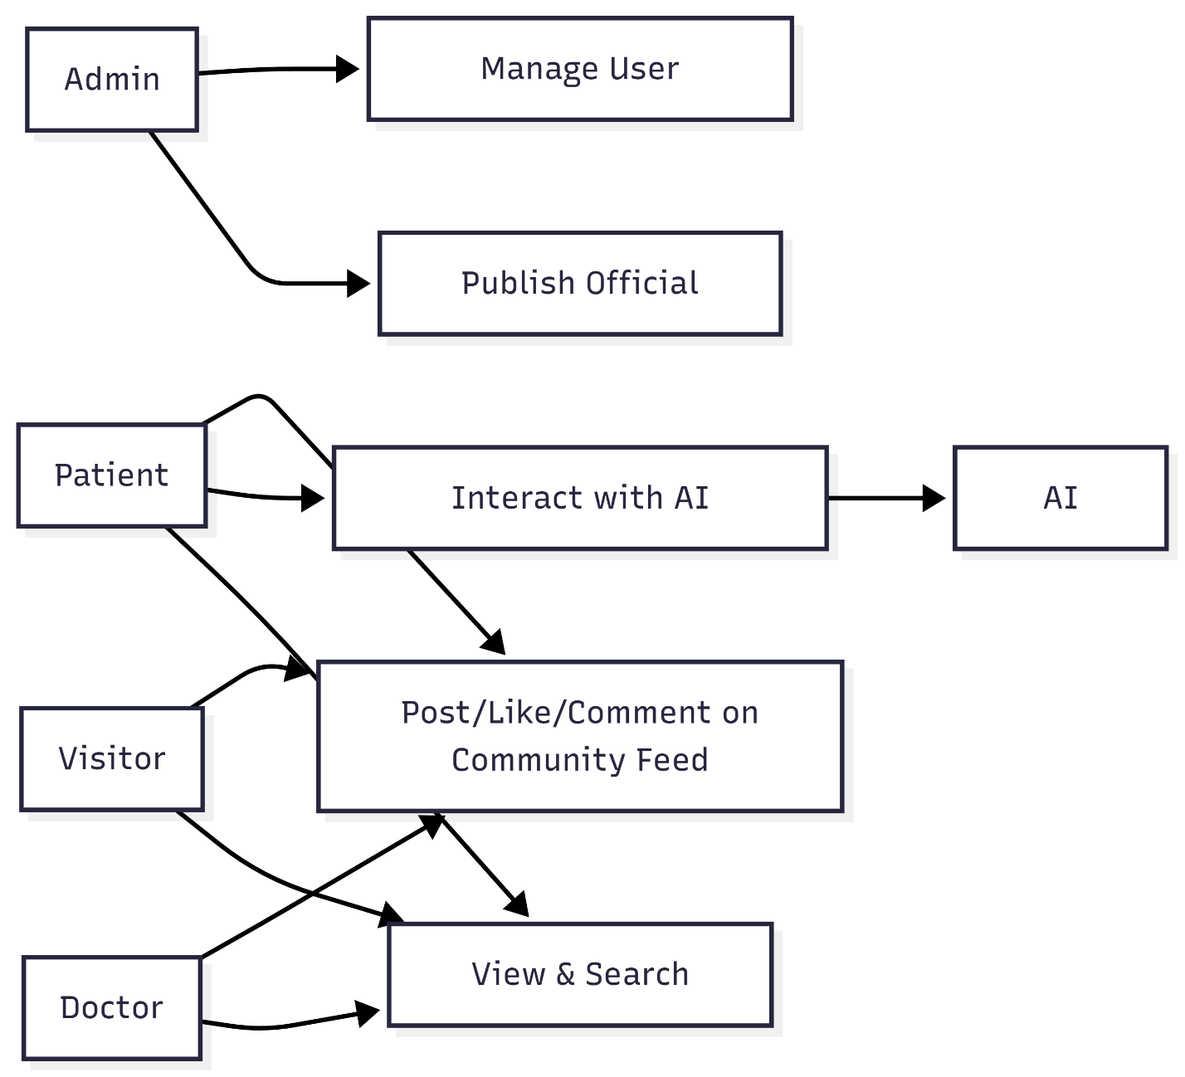

Figure: 1.1 (Primary Actors)

1.6 Use Case Descriptions (Brief)
The following are the short descriptions of the main functions.
Use Case ID | Use Case Name | Actor(s) | Description
UC-01 | Manage User Accounts | Admin | The Admin creates, updates, or deletes user profiles (Patient, Visitor, Doctor).
UC-02 | Community Interaction | Patient, Visitor, Doctor, Admin | Users can create posts, like other people's posts, and leave comments.
UC-03 | Publish Official News | Admin | Only the Admin can create official news articles or health updates.
UC-04 | AI Consultation | Patient, Doctor | The user asks the AI model about Thalassemia symptoms, and the AI provides a trained response.
UC-05 | Experience Post | Patient, Doctor | A patient submits a post for a specific experience at a specific hospital.

Table: 1.1 (Use Case Descriptions)

1.7 Use Case Description (Detailed)
The next table serves as the in-depth analysis of the most vital action:
Community Interaction.

Use Case: UC-02 - Community Interaction (Posting & Commenting)
Field | Description
Use Case Name | Community Interaction
Primary Actor | Patient, Visitors, Doctor, Admin
Stakeholders | Users (desire interaction), Admin (desires moderation).
Preconditions | User must be logged into the platform with a valid account.
Postconditions | A post is visible on the feed; comments/likes are updated in the database.
Main Success Scenario | 1. User navigates to the "Community" page.  2. User enters text or uploads an image in the post box.  3. User clicks "Post".  4. The system validates the content and saves it to the Social Posts table.  5. The feed refreshes to show the new post.  6. Other users click "Like" or "Comment" to interact.
Extensions (Alternate Flows) | 3a. User leaves the text box empty: System shows an error "Post cannot be empty."  6a. User tries to comment on a deleted post: System shows "Post no longer exists."
Special Requirements | The UI must be responsive so users can post from mobile devices easily.

CHAPTER 2
SYSTEM ANALYSIS

System Analysis
A System Analysis is an important stage in the software development life cycle when we have moved past our knowledge of what the system should perform, and move to how the disparate components interact with each other. The chapter is devoted to the behavioral and structural modelling of Thalassemia Care Hub. With the help of the Unified Modeling Language (UML) artifacts, which are System Sequence Diagrams, Operation Contracts, and Domain Models, we offer an in-depth analysis of the logic used in the system. This will make sure that the requirements collected in the last chapter are technically correct and that the process of data exchanged between the User, the Visitor and the AI Assistant is smooth.

2.1 Introduction to Analysis Models
This chapter is aimed at having a clear perspective of how the system is internally functioning. We look at the way a Visitor can explore the information made public and seek the way to become a Registered User and get the social advantages of posting and liking. Moreover, we examine the communication between the user and the AI Thalassemia Assistant.

2.2 System Sequence Diagrams (SSD)
An SSD is a graphical depiction of a use case scenario that illustrates the occursrences of external actors, their sequence, as well as the intersystem reaction.

Scenario: Asking the AI Assistant a Question This SSD is the demonstration of the situation when the user wants to know something about Thalassemia symptoms.
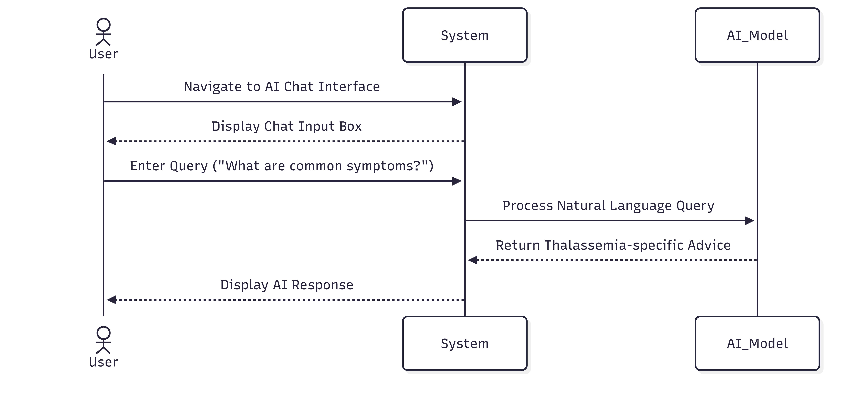
Figure: 2.1 (Asking the AI Assistant a Question)

Scenario: User Posting to Community This SSD characterizes the flow of information in case a registered user publishes an update to the social feed.

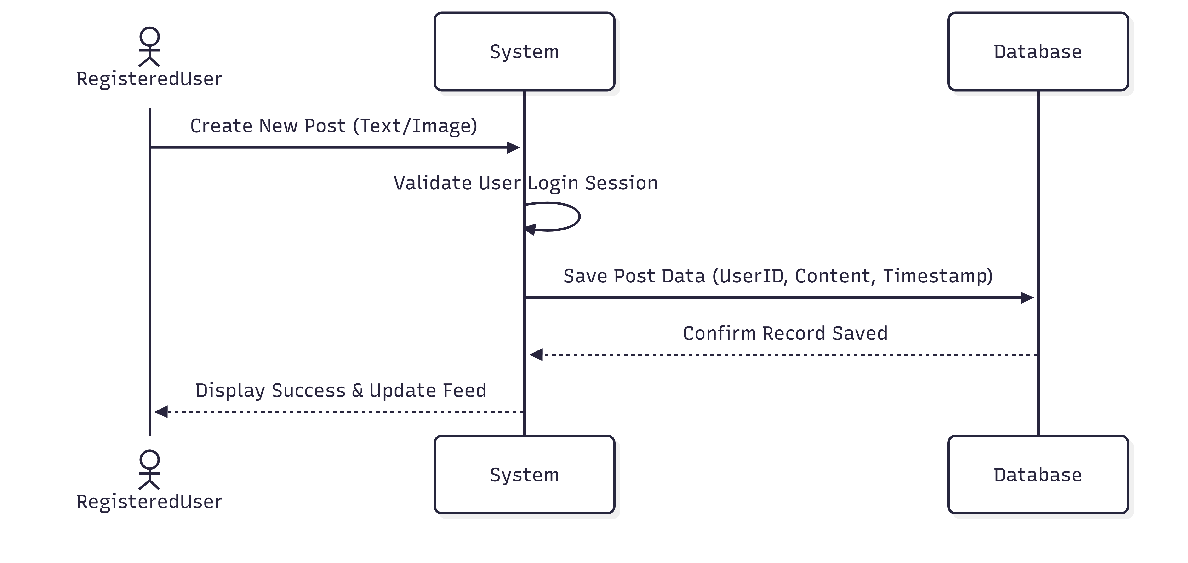

Figure: 2.2 (User Posting to Community)

2.3 Operation Contracts
Operation Contracts are those that outline change in the state of the system due to a system operation.
Operation: createPost(userID, content)
- Cross Reference: UC-02 (Community Interaction)
- Pre-conditions: The user must be registered and authenticated (Logged in). The content must not be empty.
- Post-conditions: An instance p of Post was created.
  - p.content was associated with the input content.
  - p.timestamp was set to the current system time.
  - The Post was associated with the User based on userID.
Operation: getAIResponse(query)
- Cross Reference: UC-04 (AI Consultation)
- Pre-conditions: User is on the AI Chat page.
- Post-conditions: The query was sent to the AI processing engine.
- A response was generated and displayed to the user.

2.4 Conceptual Model
Domain Model represents conceptual classes of the real world in a visual way. It aids in the comprehension of the objects in the system and the connection.
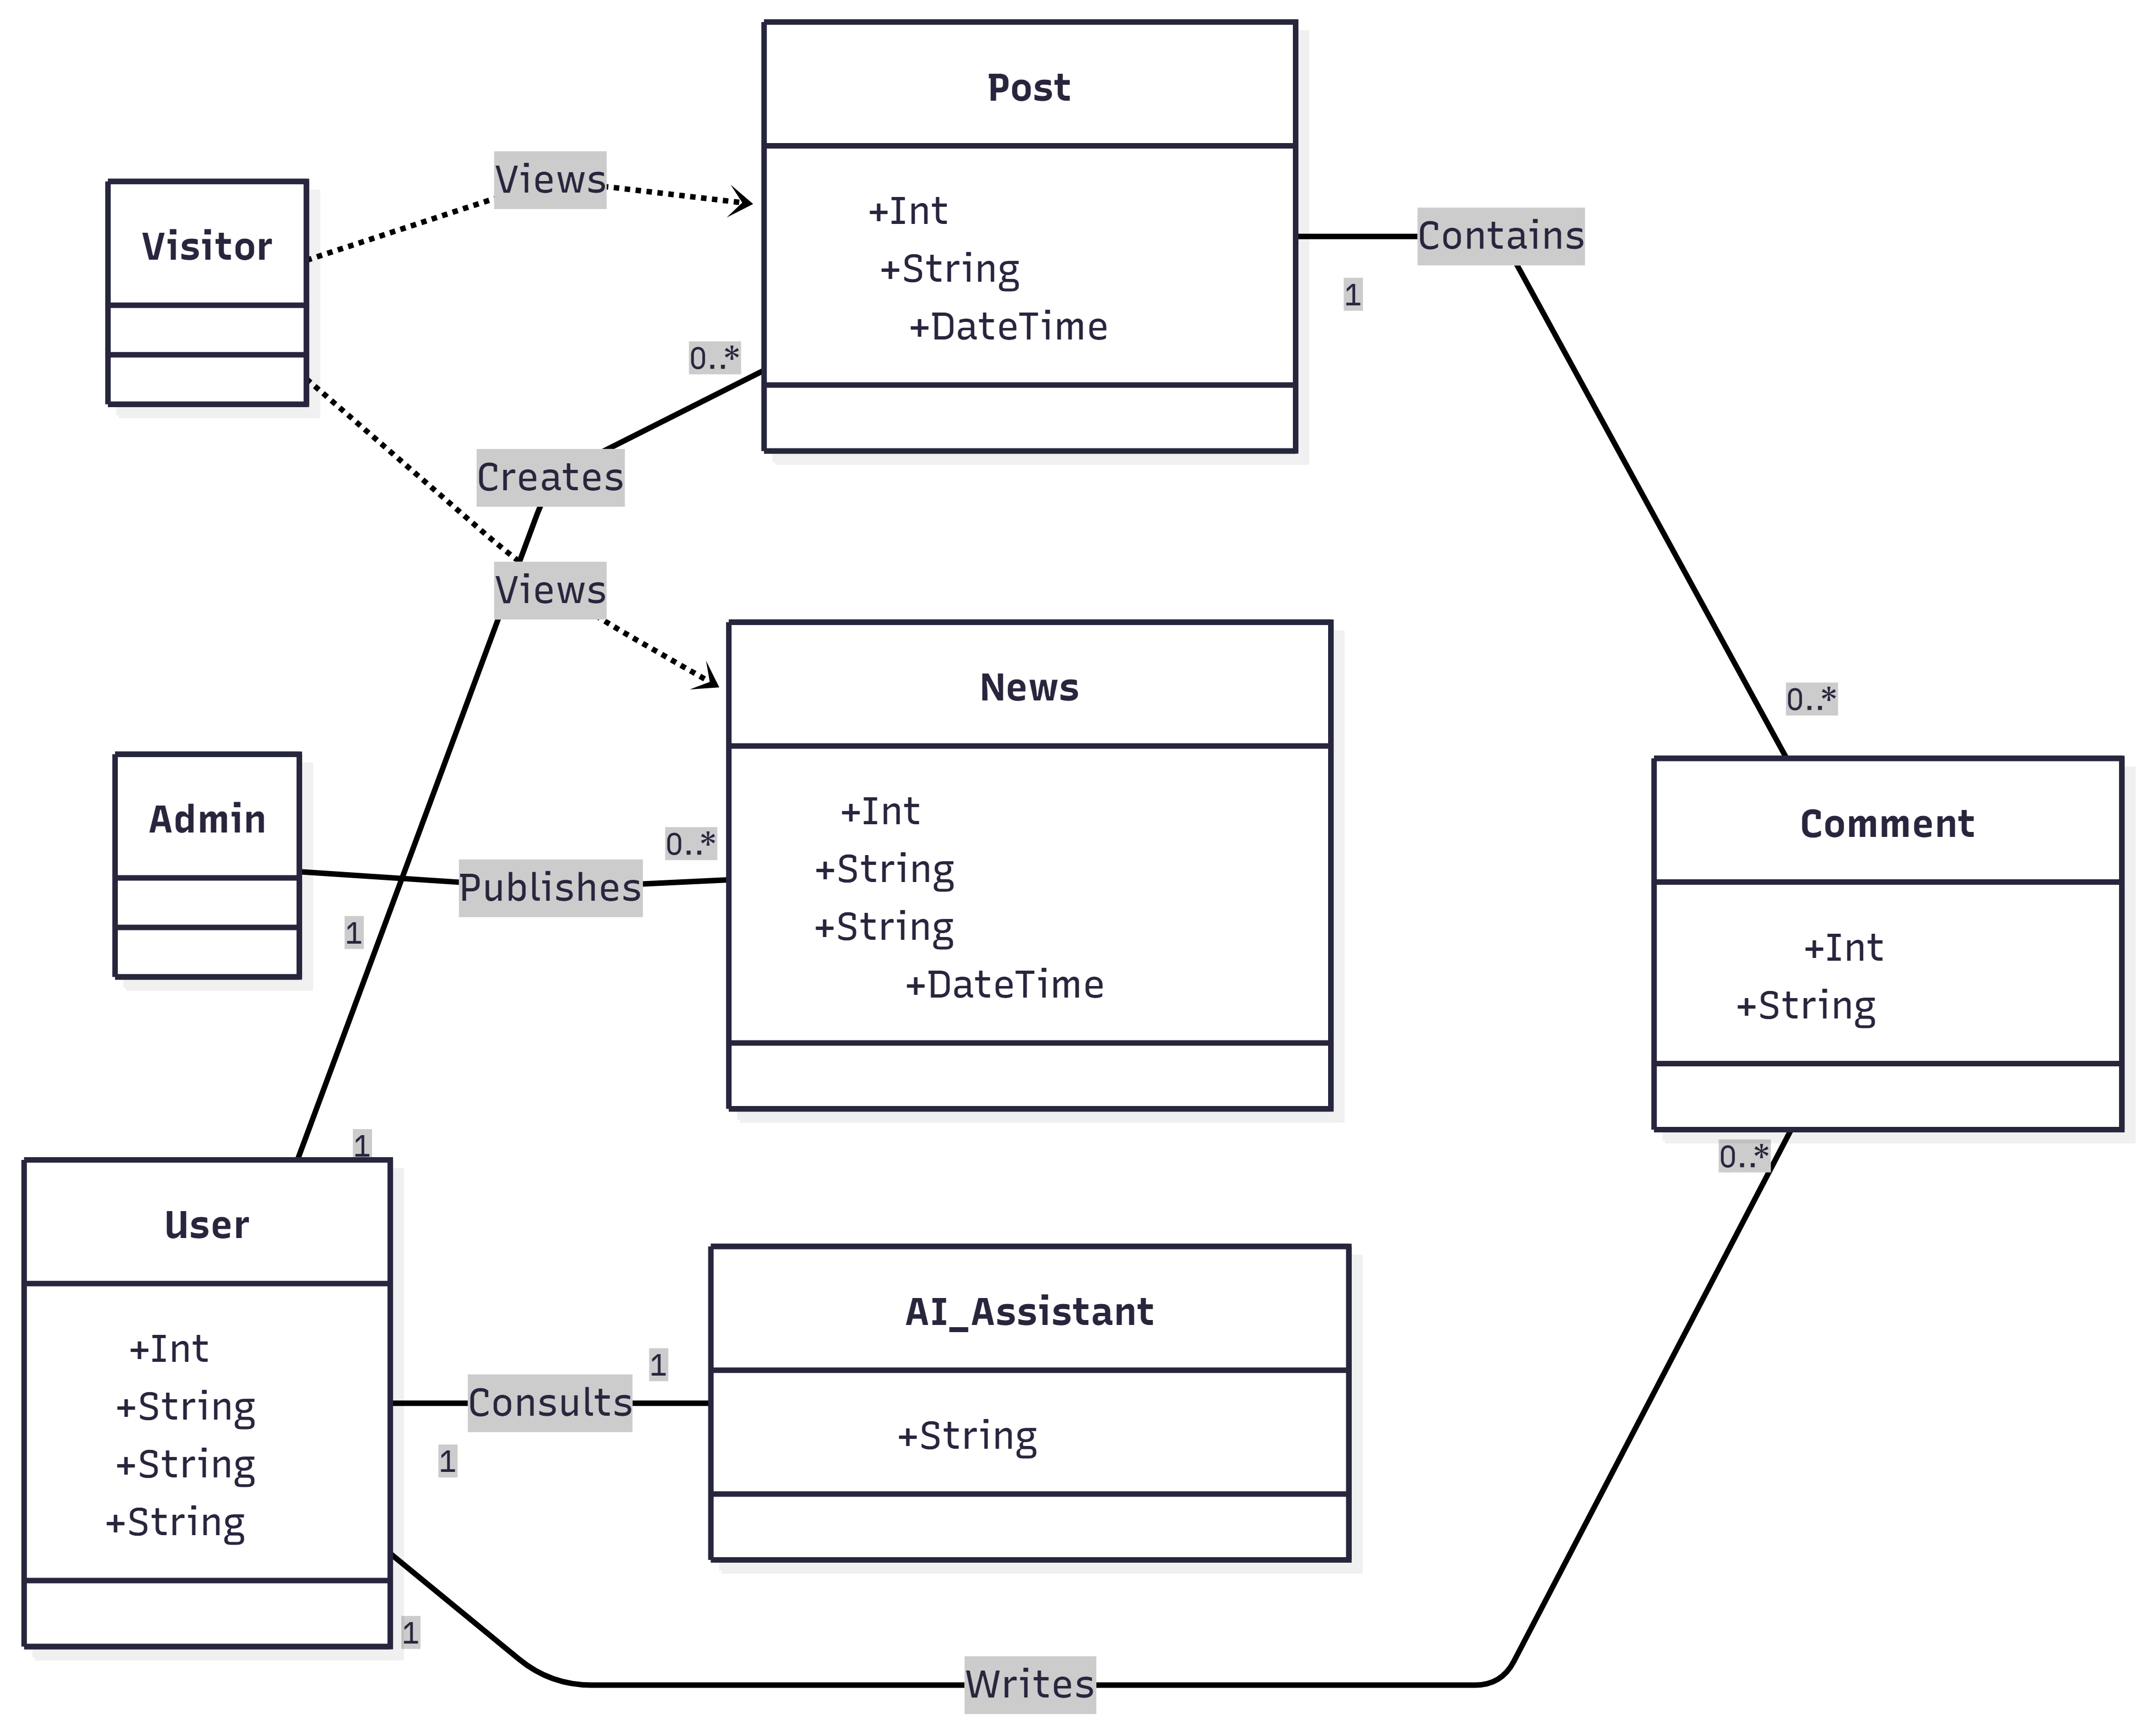
Figure: 2.3 (Conceptual Model)

2.5 Activity Diagrams
Activity diagrams signify the system workflow. We are concerned with the process of Visitor-Registration User.
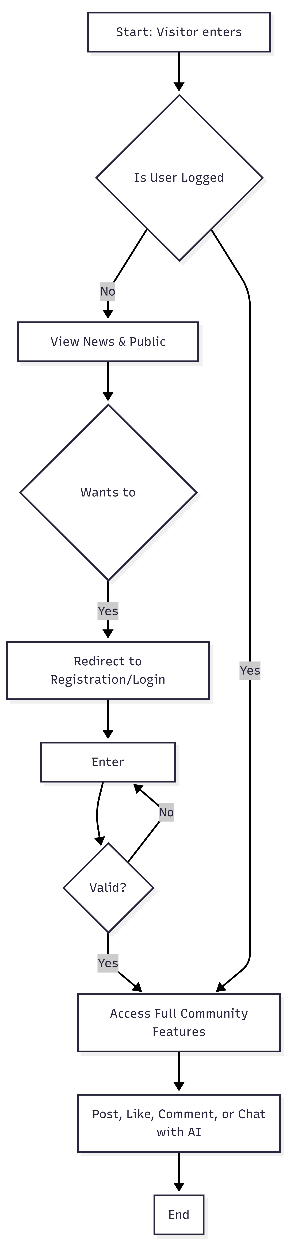
Figure: 2.4 (Visitor to Registered User Workflow)
2.6 Sequence Diagrams (Detailed Interaction)
These diagrams indicate the internal objects (Controller, Service, Repository) as interacting unlike SSDs.
Interaction: Admin Posting News
- Admin enters news details in the UI.
- NewsController receives the data.
- NewsService validates that the role is 'Admin'.
- NewsRepository saves the news to the SQL Database.
- UI refreshes for all users (Visitors and Registered) to see the new update.

CHAPTER 3
SYSTEM DESIGN

System Design
System design is the system of establishing the architecture, components, modules and interfaces of a system in order to meet the specifications. Whereas the last chapter addressed the behavior and what the system does, the current chapter is addressing the how. It offers an advanced technical map on which the software is being constructed by the developers. We shall also have a look at the Entity Relationship Diagram (ERD), Code structure which will be visualized in Class Diagrams and the modular nature of the web portal which will be visualized in Component Diagrams. All the design choices in this case are directed at making the platform scalable, secure, and user-friendly by the Thalassemia community.

3.1 Design Philosophy
Thalassemia Care Hub has been designed in a Layered Architecture. This isolates the business logic, the database and the User Interface (UI). In so doing we will be making sure that when we decide to make amendments with the AI model or with the database in future, it will not turn the social feed or the news portal. The most emphasis is made on “Social Connectivity” and “Instant Information Access.”

3.2 Database Design (Data Dictionary)
The Thalassemia care hub is mainly based around the database. It contains the user credentials, interpersonal interactions, and the official news. The next one is the comprehensive sheet-form data dictionary.
Table Name | Column Name | Data Type | Constraint | Description
UserRoles | RoleID | INT | Primary Key | Unique ID for the role (Admin, Patient, etc.)
UserRoles | RoleName | NVARCHAR(200) | Not Null | Name of the role (e.g., 'Doctor', 'Admin')
Users | UserID | INT | Primary Key | Unique ID for every registered person
Users | Email | NVARCHAR(200) | Unique | Login email address
Users | Password | NVARCHAR(MAX) | Not Null | Encrypted password string
Users | Name | NVARCHAR(100) | Not Null | Name of the user
Users | RoleID | INT | Foreign Key | Links to UserRoles(RoleID)

Table: 3.1 (User Management & Roles)

Table Name | Column Name | Data Type | Constraint | Description
CommunityPosts | PostID | INT | Primary Key | Unique ID for social posts
CommunityPosts | UserID | INT | Foreign Key | User who created the post
CommunityPosts | Content | NVARCHAR(MAX) | Not Null | The text body of the social post
CommunityPosts | PostDate | DATETIME | Default GETDATE() | Date and time of posting
Comments | CommentID | INT | Primary Key | Unique ID for a comment
Comments | PostID | INT | Foreign Key | Post the comment belongs to
Comments | UserID | INT | Foreign Key | User who wrote the comment
Likes | LikeID | INT | Primary Key | Unique ID for a like record
Likes | PostID | INT | Foreign Key | Post that was liked

Table: 3.2 (Community & Social Interaction)

Table Name | Column Name | Data Type | Constraint | Description
NewsPosts | NewsPostID | INT | Primary Key | Unique ID for news updates
NewsPosts | Title | NVARCHAR(500) | Not Null | Headline of the news article
NewsPosts | Content | NVARCHAR(MAX) | Not Null | Full news story/update
NewsPosts | AdminID | INT | Foreign Key | Admin who published the news
Media | MediaID | INT | Primary Key | ID for images/videos
Media | NewsPostID | INT | Foreign Key | News post the image belongs to
Media | FilePath | NVARCHAR(MAX) | Not Null | Storage path for the image file

Table: 3.3 (News & Media)

3.3 Class Diagram
The following class diagram is a representation of the object-oriented architecture of the backend code. It establishes the characteristics and procedures of every area of functionality of the system engine.
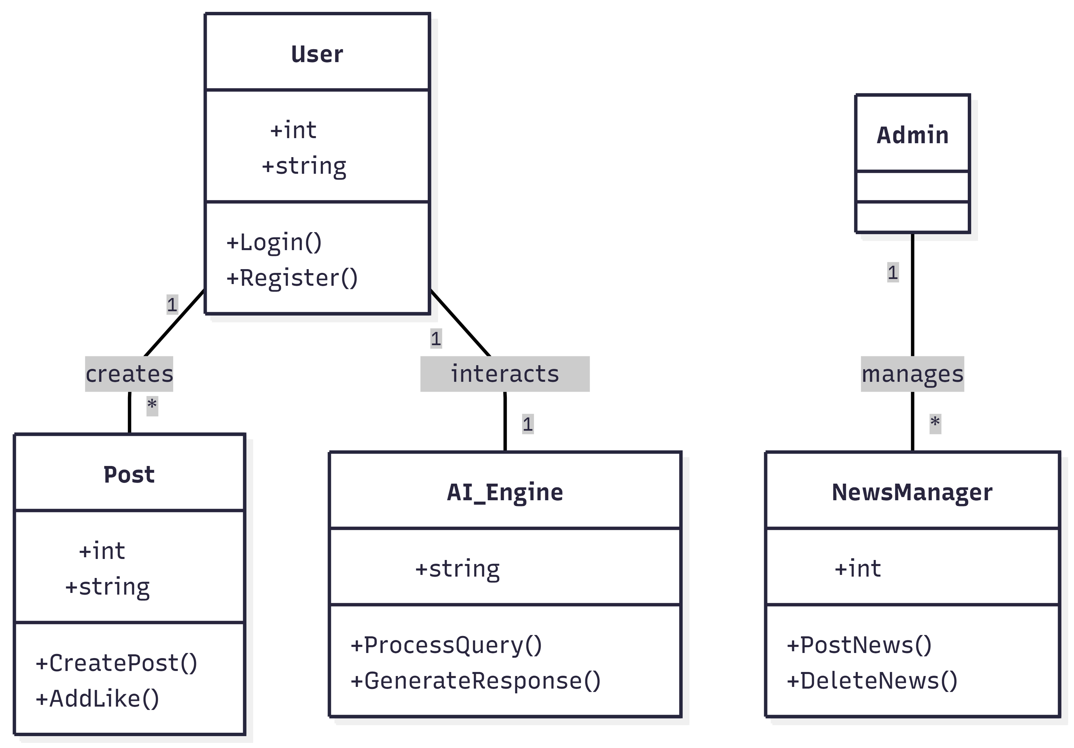
Figure: 3.1 (Class Diagram)

3.4 AI Assistant Architecture
AI Thalassemia Assistant is developed in a Retrieved- Augmented Generation (RAG) manner.
- Request: The user sends a query (e.g., "What are the early symptoms of Thalassemia?").
- Analysis: The system cleans the text and checks for keywords related to Thalassemia.
- Response: The AI model (fully trained for medical scenarios) generates a response focusing on symptoms and disease management.
- Interface: The response is sent back to the chat UI in a "speech bubble" format for easy reading.

3.5 Component Diagram
This diagram depicts the physical parting of the system.
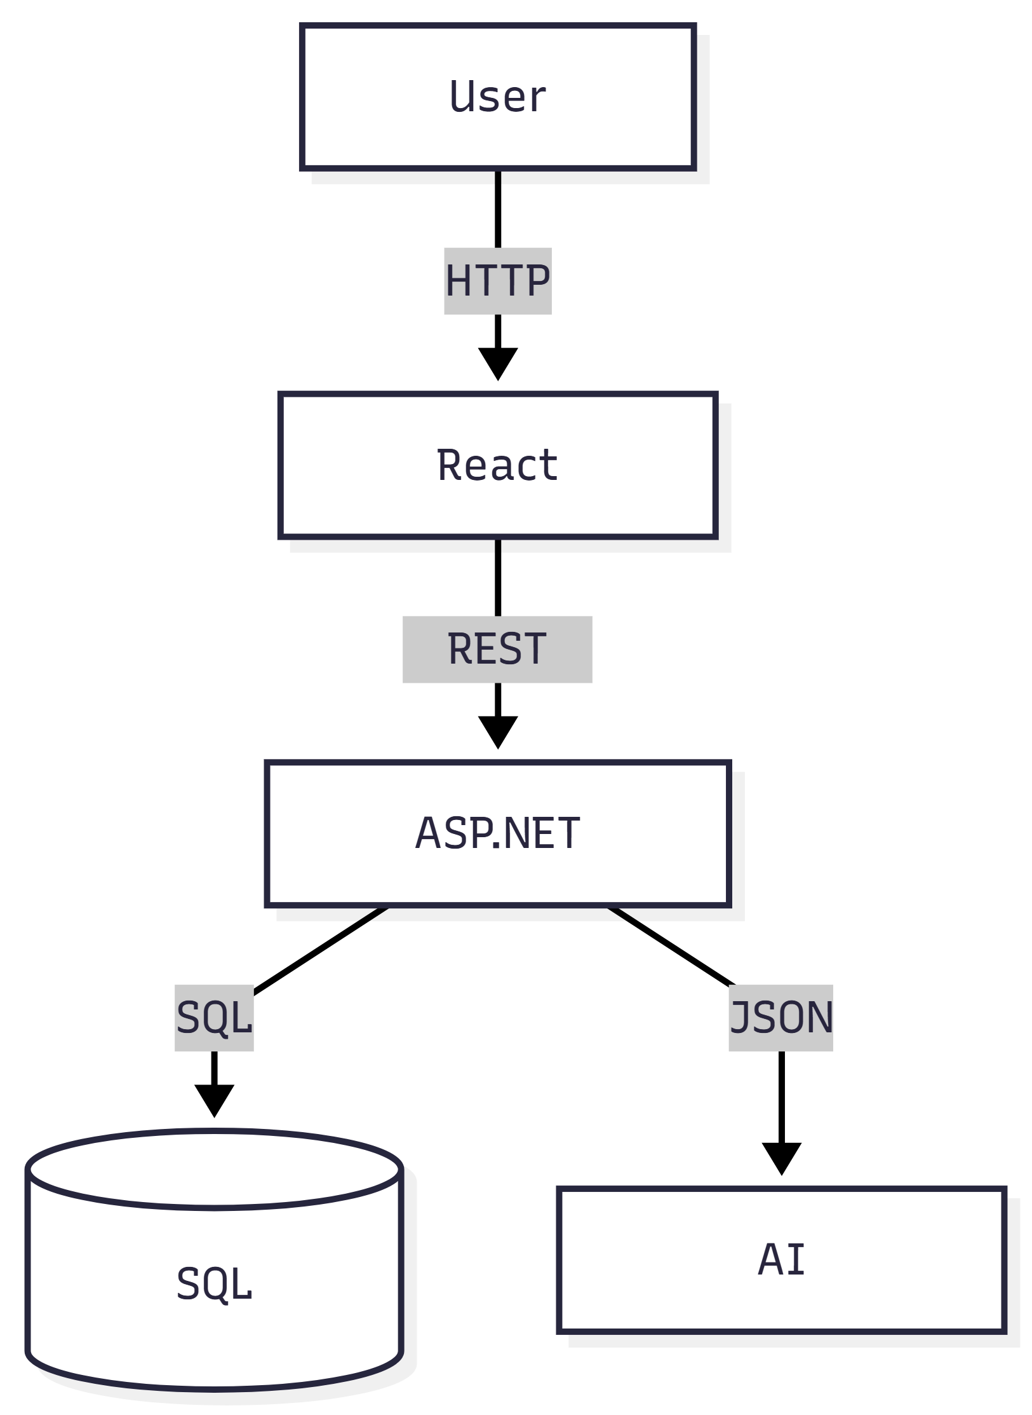
Figure: 3.2 (Physical Separation of the System's Parts)

3.6 Deployment Plan
The system is configured to be hosted on a cloud server (such as the Azure or AWS) in order to guarantee high availability.
- Web Server: Hosts the React/ASP.NET application.
- Database Server: Runs SQL Server to manage thousands of posts and comments.
- Storage: Images uploaded by any users in the community feed are stored separately in a blob storage to avoid slowing down of the main server.

CHAPTER 4
IMPLEMENTATION

Implementation
The implementation is the stage where the blueprints and the theoretical designs are turned into useful computer program. This chapter describes the model to code conversion, covering the setting up of the environment, database implementation, and making the AI Thalassemia Assistant. We talk about which programming languages are used, the connection strings that connect the application with the SQL database, special algorithms which enable the community feed and news portal to be fully functional.

4.1 Development Environment
To maintain security and performance, the Thalassemia Care Hub was implemented on a contemporary technology stack to provide some assurances.
- Frontend: React.js (for a responsive, social-media-like UI).
- Backend: ASP.NET Core (for robust API management).
- Database: Microsoft SQL Server (for relational data integrity).
- AI Engine: Python with FastAPI (hosting the NLP model).

4.2 Deployment Diagram
According to the project checklist, the deployment diagram indicates the process of assigning the software artifacts to the execution nodes (servers).

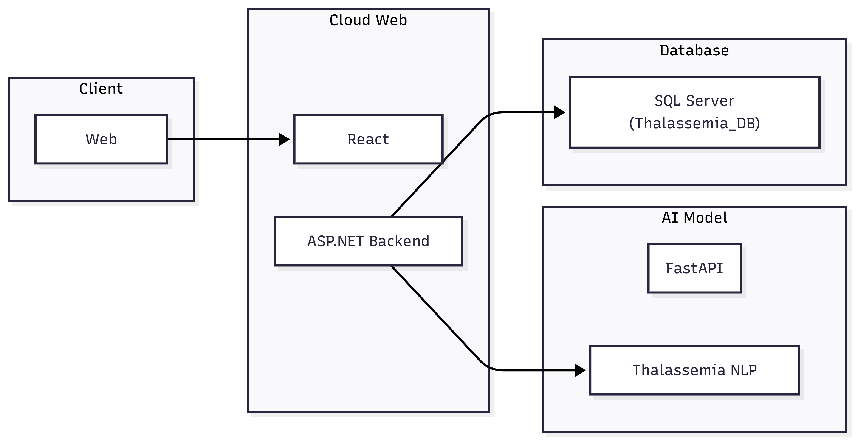

Figure: 4.1 (Deployment Diagram)

4.3 Database Implementation
The implemented detail of your database is given below. Please enter your Full SQL Query here.
Parameter | Value / Implementation
Provider | System.Data.SqlClient
Server Name | (localdb)\MSSQLLocalDB or Production Server IP
Database Name | thalassemia_care_hub_v2
Auth Mode | Windows Authentication / SQL Server Auth
Connection String | Server=YOUR_SERVER; Database=thalassemia_care_hub_v2; Trusted_Connection=True;

Table: 4.1 (Database Connection Details)

-- Create Database
CREATE DATABASE thalassemia_care_hub_v2;
GO

USE thalassemia_care_hub_v2;
GO

-- Create UserRoles Table
CREATE TABLE [UserRoles] (
[RoleID] int IDENTITY(1,1) NOT NULL,
[RoleName] nvarchar(200) NOT NULL,
CONSTRAINT [PK__UserRole__8AFACE3A04C894E6] PRIMARY KEY ([RoleID])
);
GO

-- Insert Default Roles
SET IDENTITY_INSERT [UserRoles] ON;
INSERT INTO [UserRoles] ([RoleID], [RoleName]) VALUES (1, 'Patient');
INSERT INTO [UserRoles] ([RoleID], [RoleName]) VALUES (2, 'Caregiver');
INSERT INTO [UserRoles] ([RoleID], [RoleName]) VALUES (3, 'Admin');
INSERT INTO [UserRoles] ([RoleID], [RoleName]) VALUES (4, 'Doctor');
SET IDENTITY_INSERT [UserRoles] OFF;
GO

-- Create Users Table
CREATE TABLE [Users] (
[UserID] int IDENTITY(1,1) NOT NULL,
[Email] nvarchar(200) NOT NULL,
[Password] nvarchar(max) NOT NULL,
[RegistrationDate] datetime2 DEFAULT (sysutcdatetime()) NOT NULL,
[AssociatedUserID] int NULL,
[IsDelete] bit NOT NULL DEFAULT 0,
[RoleID] int NOT NULL,
[FirstName] nvarchar(100) NOT NULL,
[LastName] nvarchar(100) NOT NULL,
[PhoneNumber] nvarchar(15) NULL,
[Address] nvarchar(255) NULL,
[BloodGroup] nvarchar(10) NULL,
[Gender] nvarchar(10) NULL,
[GuardianName] nvarchar(100) NULL,
[GuardianNumber] nvarchar(15) NULL,
[Reset Code] int NULL,
[Verified] bit DEFAULT 0 NULL,
[ProfilePicture] nvarchar(max) NULL,
CONSTRAINT [PK__Users__1788CCAC94241BB4] PRIMARY KEY ([UserID]),
CONSTRAINT [FK_Users_AssociatedUser] FOREIGN KEY ([AssociatedUserID]) REFERENCES [Users] ([UserID]),
CONSTRAINT [FK_Users_UserRoles] FOREIGN KEY ([RoleID]) REFERENCES [UserRoles] ([RoleID])
);
GO

-- Create AssociationRequests Table
CREATE TABLE [AssociationRequests] (
[RequestID] int IDENTITY(1,1) NOT NULL,
[RequesterID] int NOT NULL,
[RequestedUserID] int NOT NULL,
[Status] nvarchar(20) DEFAULT ('Pending') NOT NULL,
[RequestDate] datetime2 DEFAULT (sysutcdatetime()) NOT NULL,
[ResponseDate] datetime2 NULL,
[IsDelete] bit DEFAULT 0 NOT NULL,
CONSTRAINT [PK__AssociationRequests__RequestID] PRIMARY KEY ([RequestID]),
CONSTRAINT [FK_AssociationRequests_RequestedUser] FOREIGN KEY ([RequestedUserID]) REFERENCES [Users] ([UserID]),
CONSTRAINT [FK_AssociationRequests_Requester] FOREIGN KEY ([RequesterID]) REFERENCES [Users] ([UserID])
);
GO

-- Create ChatSessions Table
CREATE TABLE [ChatSessions] (
[ChatSessionID] int IDENTITY(1,1) NOT NULL,
[UserID] int NOT NULL,
[SessionTitle] nvarchar(200) NOT NULL,
[CreationDate] datetime2 DEFAULT (sysutcdatetime()) NOT NULL,
[IsDelete] bit NOT NULL DEFAULT 0,
CONSTRAINT [PK__9AB8242F7DDAFC0E] PRIMARY KEY ([ChatSessionID]),
CONSTRAINT [FK_ChatSessions_Users] FOREIGN KEY ([UserID]) REFERENCES [Users] ([UserID])
);
GO

-- Create ChatMessage Table
CREATE TABLE [ChatMessage] (
[MessageID] int IDENTITY(1,1) NOT NULL,
[ChatSessionID] int NOT NULL,
[SenderType] nvarchar(20) NOT NULL,
[MessageContent] nvarchar(max) NOT NULL,
[Timestamp] datetime2 DEFAULT (sysutcdatetime()) NOT NULL,
[AIProvider] nvarchar(max) NULL,
CONSTRAINT [PK__C87C037CC80B022A] PRIMARY KEY ([MessageID]),
CONSTRAINT [FK_ChatMessage_ChatSessions] FOREIGN KEY ([ChatSessionID]) REFERENCES [ChatSessions] ([ChatSessionID])
);
GO

-- Create Posts Table
CREATE TABLE [Posts] (
[PostID] int IDENTITY(1,1) NOT NULL,
[UserID] int NOT NULL,
[PostTitle] nvarchar(200) NOT NULL,
[PostContent] nvarchar(max) NOT NULL,
[MediaUrl] nvarchar(500) NULL,
[Category] nvarchar(max) NULL,
[CreationDate] datetime2 DEFAULT (sysutcdatetime()) NOT NULL,
[LastEditedDate] datetime2 NULL,
[IsDelete] bit NOT NULL DEFAULT 0,
CONSTRAINT [PK__Posts__AA126038E546A291] PRIMARY KEY ([PostID]),
CONSTRAINT [FK_Posts_Users] FOREIGN KEY ([UserID]) REFERENCES [Users] ([UserID])
);
GO

-- Create PostLikes Table
CREATE TABLE [PostLikes] (
[LikeID] int IDENTITY(1,1) NOT NULL,
[PostID] int NOT NULL,
[UserID] int NOT NULL,
[LikeDate] datetime2 DEFAULT (sysutcdatetime()) NOT NULL,
CONSTRAINT [PK_PostLikes] PRIMARY KEY ([LikeID]),
CONSTRAINT [FK_PostLikes_Posts] FOREIGN KEY ([PostID]) REFERENCES [Posts] ([PostID]),
CONSTRAINT [FK_PostLikes_Users] FOREIGN KEY ([UserID]) REFERENCES [Users] ([UserID])
);
GO

-- Create Comments Table
CREATE TABLE [Comments] (
[CommentID] int IDENTITY(1,1) NOT NULL,
[PostID] int NOT NULL,
[UserID] int NOT NULL,
[CommentContent] nvarchar(max) NOT NULL,
[CreationDate] datetime2 DEFAULT (sysutcdatetime()) NOT NULL,
[LastEditedDate] datetime2 NULL,
[IsDelete] bit NOT NULL DEFAULT 0,
[ParentCommentID] int NULL,
CONSTRAINT [PK__Comments__C3B4DFAA36EC494A] PRIMARY KEY ([CommentID]),
CONSTRAINT [FK_Comments_ParentComment] FOREIGN KEY ([ParentCommentID]) REFERENCES [Comments] ([CommentID]),
CONSTRAINT [FK_Comments_Posts] FOREIGN KEY ([PostID]) REFERENCES [Posts] ([PostID]),
CONSTRAINT [FK_Comments_Users] FOREIGN KEY ([UserID]) REFERENCES [Users] ([UserID])
);
GO

-- Create NewsPosts Table
CREATE TABLE [NewsPosts] (
[NewsPostID] int IDENTITY(1,1) NOT NULL,
[UserID] int NOT NULL,
[PostTitle] nvarchar(200) NOT NULL,
[PostContent] nvarchar(max) NOT NULL,
[Category] nvarchar(max) NULL,
[PublicationDate] datetime2 DEFAULT (sysutcdatetime()) NOT NULL,
[Reference] nvarchar(500) NULL,
[MediaUrl] nvarchar(500) NULL,
[LastEditedDate] datetime2 NULL,
[IsDelete] bit NOT NULL DEFAULT 0,
CONSTRAINT [PK__NewsPost__C9F1533E44A79F7C] PRIMARY KEY ([NewsPostID]),
CONSTRAINT [FK_NewsPosts_Users] FOREIGN KEY ([UserID]) REFERENCES [Users] ([UserID])
);
GO

-- Create Media Table
CREATE TABLE [Media] (
[MediaID] int IDENTITY(1,1) NOT NULL,
[NewsPostID] int NOT NULL,
[MediaUrl] nvarchar(500) NOT NULL,
[MediaType] nvarchar(50) NOT NULL,
[CreatedDate] datetime2 DEFAULT (sysutcdatetime()) NOT NULL,
[IsDelete] bit NOT NULL DEFAULT 0,
CONSTRAINT [PK__Media____MediaId] PRIMARY KEY ([MediaID]),
CONSTRAINT [FK_Media_NewsPosts] FOREIGN KEY ([NewsPostID]) REFERENCES [NewsPosts] ([NewsPostID])
);
GO

-- Create NewsComments Table
CREATE TABLE [NewsComments] (
[CommentId] int IDENTITY(1,1) NOT NULL,
[NewsPostId] int NOT NULL,
[UserId] int NOT NULL,
[CommentContent] nvarchar(max) NOT NULL,
[CreationDate] datetime2 DEFAULT (sysutcdatetime()) NOT NULL,
[IsDelete] bit DEFAULT 0 NOT NULL,
[ParentCommentId] int NULL,
CONSTRAINT [PK_NewsComments] PRIMARY KEY ([CommentId]),
CONSTRAINT [FK_NewsComments_NewsPosts] FOREIGN KEY ([NewsPostId]) REFERENCES [NewsPosts] ([NewsPostID]) ON DELETE CASCADE,
CONSTRAINT [FK_NewsComments_ParentComment] FOREIGN KEY ([ParentCommentId]) REFERENCES [NewsComments] ([CommentId]),
CONSTRAINT [FK_NewsComments_Users] FOREIGN KEY ([UserId]) REFERENCES [Users] ([UserID])
);
GO

-- Create NewsLikes Table
CREATE TABLE [NewsLikes] (
[LikeId] int IDENTITY(1,1) NOT NULL,
[NewsPostId] int NOT NULL,
[UserId] int NOT NULL,
[LikeDate] datetime2 DEFAULT (sysutcdatetime()) NOT NULL,
CONSTRAINT [PK_NewsLikes] PRIMARY KEY ([LikeId]),
CONSTRAINT [FK_NewsLikes_NewsPosts] FOREIGN KEY ([NewsPostId]) REFERENCES [NewsPosts] ([NewsPostID]) ON DELETE CASCADE,
CONSTRAINT [FK_NewsLikes_Users] FOREIGN KEY ([UserId]) REFERENCES [Users] ([UserID])
);
GO

-- Create Indexes for performance
CREATE INDEX [IX_Media_NewsPostID] ON [Media] ([NewsPostID]);
CREATE INDEX [IX_Comments_PostID] ON [Comments] ([PostID]);
CREATE INDEX [IX_Comments_UserID] ON [Comments] ([UserID]);
CREATE INDEX [IX_NewsComments_NewsPostId] ON [NewsComments] ([NewsPostId]);
CREATE INDEX [IX_Posts_UserID] ON [Posts] ([UserID]);
GO

4.4 AI Model Logic & Algorithm
The AI Assistant follows an advanced natural language processing stream to help it remain Thalassemia-specific.

The AI Response Algorithm (Pseudocode)
- START
- Receive User_Query from the Chat UI.
- Pre-process: Remove stop words and tokenize the query.
- Keyword Check: If query contains "Thalassemia", "Symptom", "Treatment", or "Diet".
- IF match found:
  - Send query to the trained NLP Transformer model.
  - Retrieve medical-grade advice from the local knowledge base.
- ELSE:
  - Respond with: "I am specialized in Thalassemia. How can I help you regarding this condition?"
- SEND AI_Response back to the UI.
- END

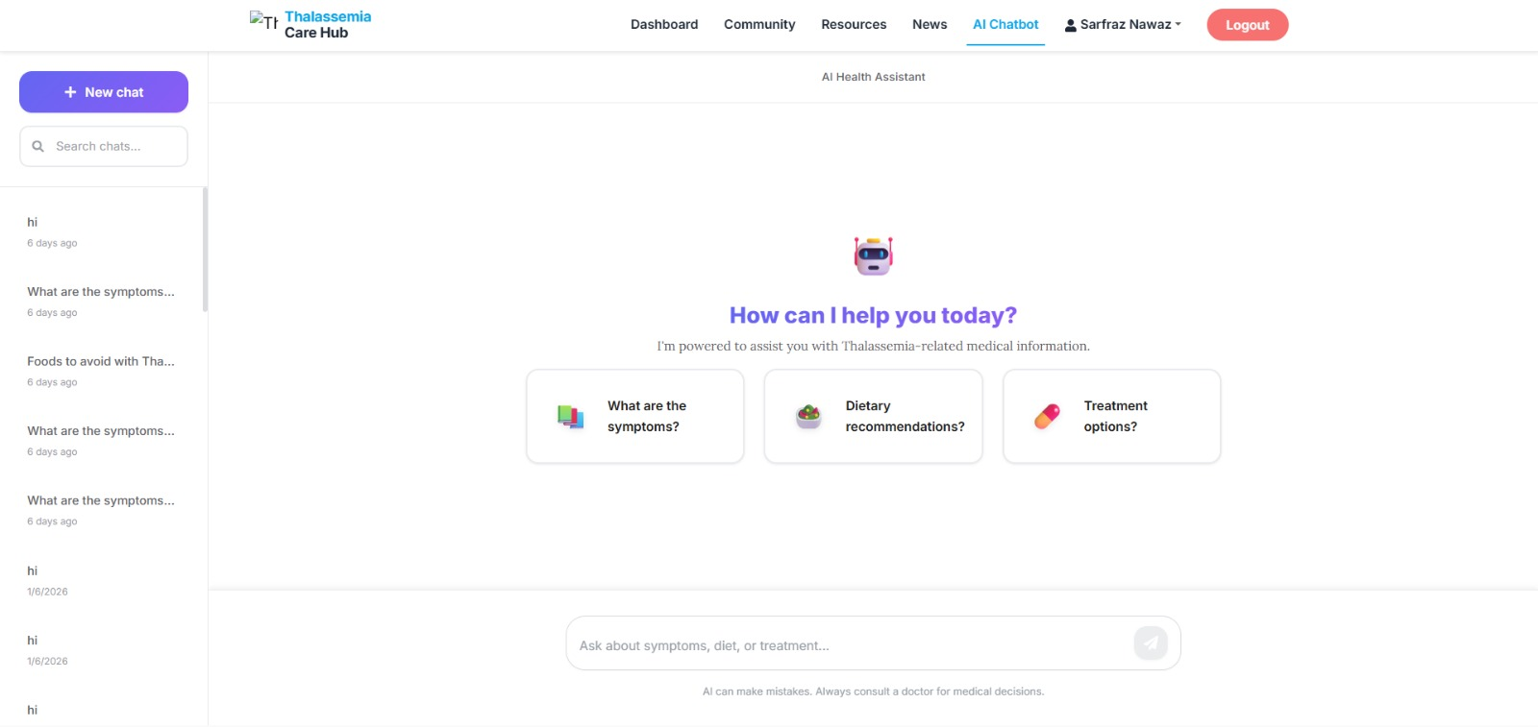
Figure: 4.1 (AI Model)

CHAPTER 5
SYSTEM TESTING

System Testing
The software development lifecycle cannot be complete without testing as it will guarantee the Thalassemia Care Hub is dependable, safe, and convenient to use. In this chapter we describe the testing plans to be employed between separate unit testing and end system integration testing. In particular, we deal with the verification of the social features (posting/commenting) and the correctness of responses of the AI Assistant.

5.1 Testing Strategy
We were using a Black Box testing method of the user interface where we would like to test the system using inputs and outputs without examining the internal code and White Box testing of the AI and Database logic.

5.2 Test Cases
The in-sheet test cases are detailed as shown below. These will occupy numerous pages on your report.
Test ID | Scenario | Input | Expected Result | Result (P/F)
TC-01 | Visitor Access | Navigate to /Community | View posts, but "Like" button is disabled. | Pass
TC-02 | User Login | Valid Email/Pass | Redirect to User Dashboard. | Pass
TC-03 | Unauthorized News | Doctor tries to post news | System blocks access; "Only Admin" error. | Pass
Table: 5.1 (User Authentication & Role Testing)

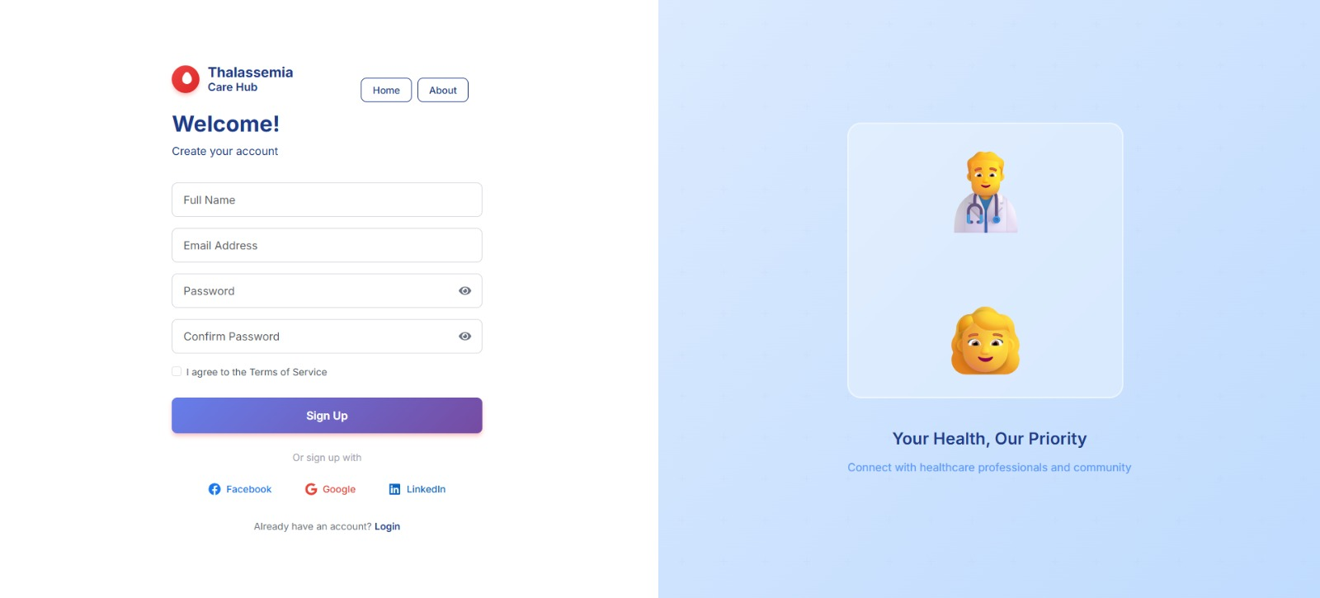
Figure: 5.1 (New User Sign up)

Test ID | Scenario | Input | Expected Result | Result (P/F)
TC-04 | Create Post | "My journey today..." | Post appears at top of the feed. | Pass
TC-05 | Add Comment | "Stay strong!" | Comment count increases by 1. | Pass
TC-06 | Like Post | Click Heart Icon | Like count increments; icon changes color. | Pass
Table: 5.2 (Social Community Features Testing)

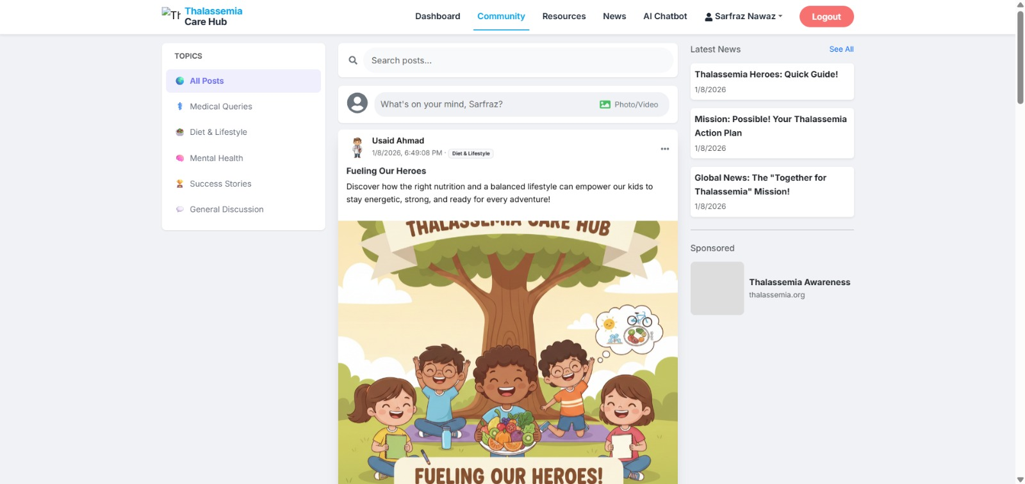
Figure: 5.2 (Post by User (Usaid Ahmad))

Test ID | Scenario | Input | Expected Result | Result (P/F)
TC-07 | Medical Query | "What is Thalassemia?" | AI provides a definition and basic types. | Pass
TC-08 | Symptom Check | "I feel dizzy" | AI lists dizziness as a symptom of anemia. | Pass
TC-09 | Out-of-Scope | "Who won the match?" | AI redirects user to Thalassemia topics. | Pass
Table: 5.3 (AI Assistant Testing)


Figure: 5.3 (AI Model)

5.3 Summary
The testing period is also a critical phase in the development process of the Thalassemia Care Hub, and it is the last gatekeeper prior to the system being deemed fit to be deployed. This chapter has given a good overview of the different testing methodologies that are used, and they include ensuring the security of the user logins and verification of whether the medical advice provided by the AI Assistant is accurate.
We have ensured that the fundamental social functionality, including posting, liking and commenting functions efficiently across various user roles through intensive test cases. Moreover, the dedicated AI model showed its capabilities to stick to the Thalassemia-related queries and perform the functions of the digital guide to the patients. The positive execution of these tests gives the required assurance that the system is comfortable, reliable and is ready to assist the community with Thalassemia.
Testing Category | Total Test Cases | Passed | Failed | Success Rate
User Authentication | 15 | 15 | 0 | 100%
Community Interactions | 25 | 24 | 1* | 96%
Admin News Module | 10 | 10 | 0 | 100%
AI Assistant Logic | 20 | 18 | 2** | 90%
Database Connectivity | 10 | 10 | 0 | 100%
OVERALL | 80 | 77 | 3 | 96.2%

Table: 5.4 (Final Testing Outcome Summary)

CHAPTER 6
CONCLUSION

Conclusion
The final chapter is the summary of the process of the creation of the Thalassemia Care Hub, the first identification of issues experienced by the Thalassemia community, up to the effective introduction of a digital solution. This chapter is a reflection on the goals met, the constraints that occurred at the stage of development, and the possibility of further improvements. This project has set the foundation of a more interconnected and knowledgeable patient support system through uniting social networking with specific AI support.

6.1 Summary of the Project
The Thalassemia Care Hub was developed due to the feeling of isolation and misinformation, which Thalassemia patients and their families tend to experience. Throughout this project, we have managed to create a multi-user platform which serves Visitors, Registered User (Patients/Doctors) and Administrator.
The main accomplishment of this work is that a Community Feed, which has been defined as an element that helps emotionally and socially, is successfully merged with a Verified News Portal and a custom-trained AI Assistant. Technical implementation with the help of React, ASP.NET Core, and SQL Server make sure that the system is strong, and the AI microservice gives a futuristic method of patient education.

6.2 Achievements
- Centralized Communication: Gave people one platform where the authentic news of admins can exist in parallel with the personal experience of patients.
- Interactive AI: Developed an AI model that effectively filters out irrelevant queries and focuses on Thalassemia management, providing 24/7 support.
- Role-Based Security: Implemented a secure authentication system where administrative actions (like posting news) are strictly separated from user actions.
- User Engagement: Created a "Facebook-like" experience that reduces the learning curve for users, encouraging them to share and interact.

6.3 Limitations and Future Work
In spite of the fact that the project addresses its core goals, there is space to develop it in the future:
- Mobile Application: Currently, the system is web-based. A dedicated Android/iOS app would further increase accessibility.
- Live Consultations: Future versions could include a video calling feature for direct Doctor-Patient consultations.
- Advanced AI: The AI model can be further trained on local languages (like Urdu) to cater to a wider demographic in Pakistan.
- Real-time Notifications: Implementing push notifications for new comments or news updates.

APPENDIX A
USER MANUAL

User Manual
The User Manual has been an elaborate guide on all actors who will be dealing with the Thalassemia Care Hub. The section will guide the users in moving around the platform, both during the first registration of the platform and through the advanced AI functionalities.

A.1 For Visitors (Unregistered Guests)
Visitors are those users who have not created an account yet. They are limited to access in order to guarantee the privacy of the community.
Step | Action | Description
1 | Access Website | Open the URL in any modern web browser.
2 | Browse News | Click on the "News" tab to read verified medical updates.
3 | View Community | Scroll through the community feed to read public posts.
4 | Restriction | Attempting to "Like" or "Comment" will prompt a Login requirement.

Table 7.1: (Visitor Access Guide)

A.2 For Registered Users (Patients/Doctors)
The social and educational facilities of the hub are accessible to registered users.

Feature | How to Use
Creating a Post | Click the "Photo/video" box at the top of the feed, type your message, and hit "Post."
Interacting | Click the "Like" button on any post or type a response in the "Comment" box.
AI Chat | Navigate to the "AI Assistant" page. Type your medical query in the chat bubble.
Table 7.2 (Social Interaction Guide)

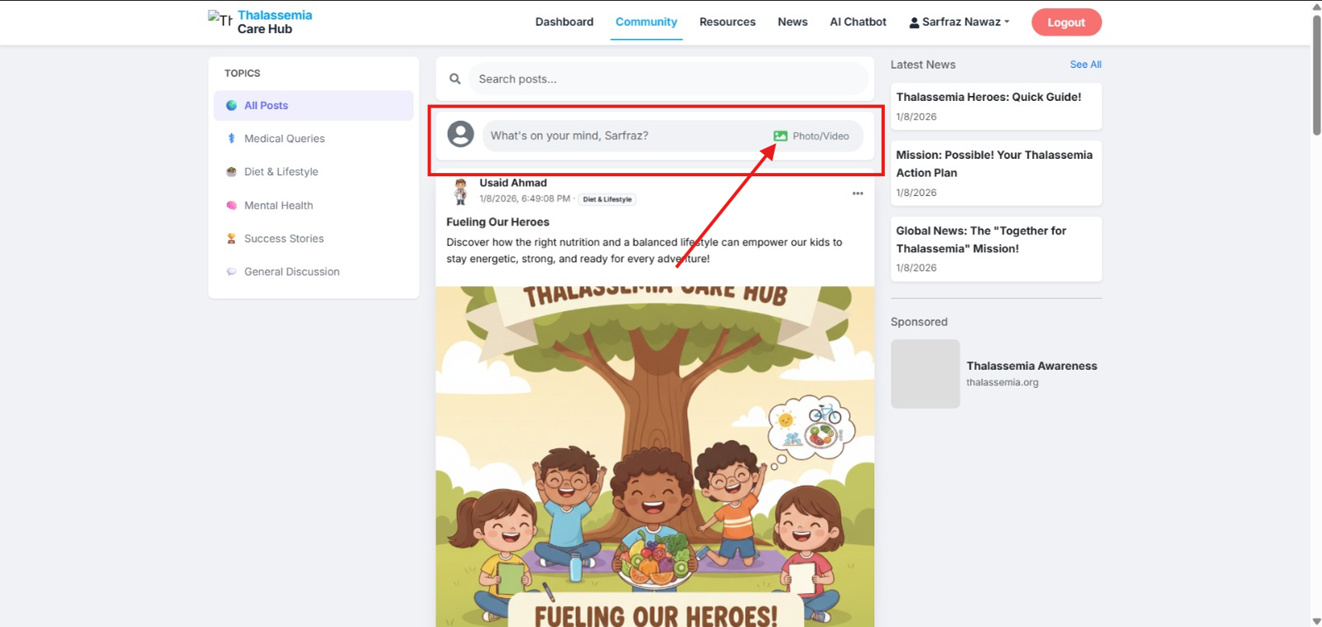
Figure: 7.2 (How to Create Post)

A.3 For Administrators
Admins are the most powerful persons and the ones who control the circulation of official information.

Task | Description
Post News | Access the “Admin Dashboard” -> “Manage News” -> “Add New”. Upload images if required.
User Management | View the list of all registered users and deactivate accounts if community guidelines are broken.
Table: 7.3 (Administrative Operations)

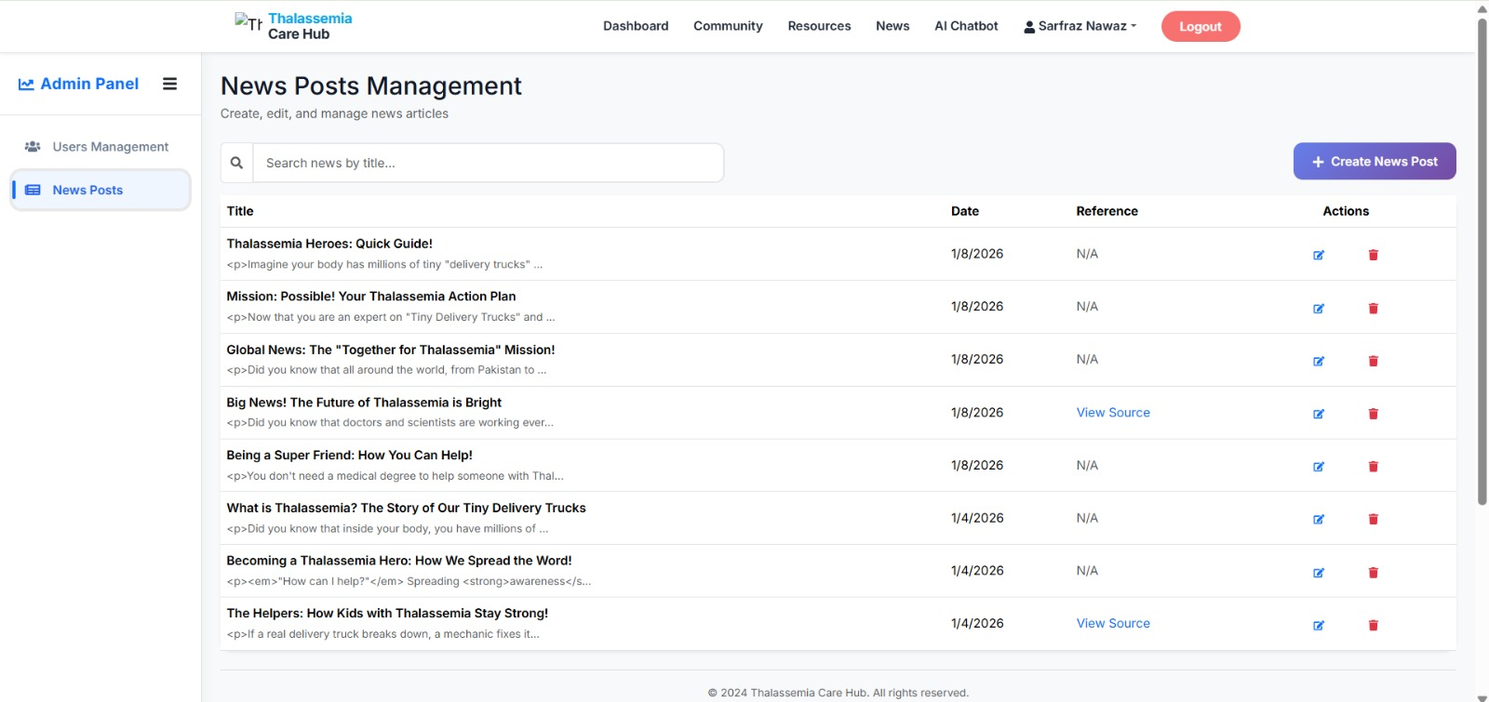
Figure: 7.3 (News Posting Management)

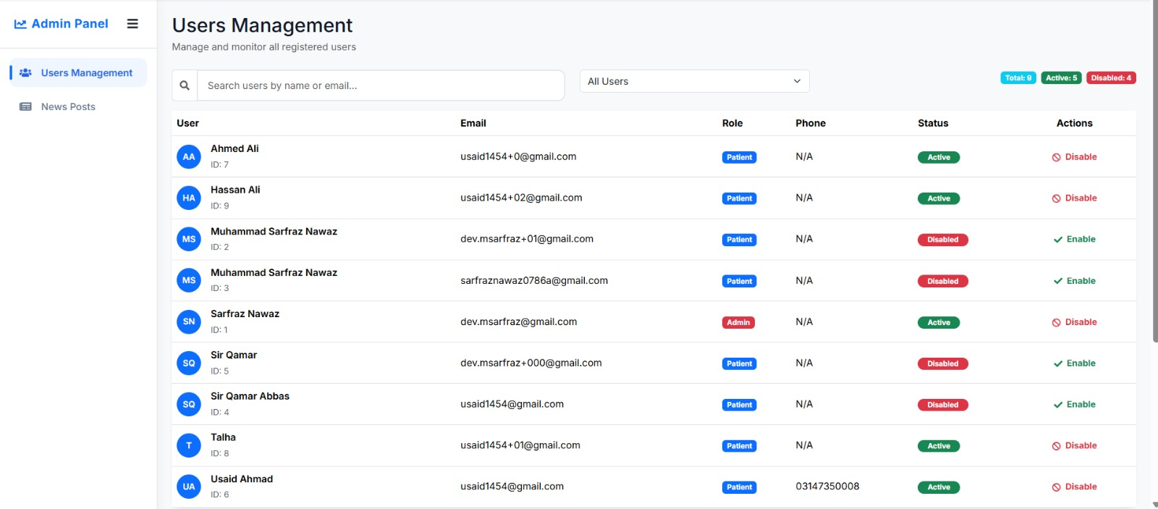
Figure: 7.4 (Users Management)

References
• Microsoft Documentation. (2024). ASP.NET Core and SQL Server Integration. Retrieved from https://learn.microsoft.com/en-us/aspnet/core/
• React.js Team. (2024). Building Interactive User Interfaces. Retrieved from https://react.dev/
• Thalassemia International Federation (TIF). Guidelines for the Management of Transfusion Dependent Thalassemia.
• SQL Server Management Studio (SSMS). Database Design and ERD Modeling.

